**Codes are provided at the end.**

a) Sample error: 15.520228104202692

The best cubic fit to this data:

W3 = -18.3959749927282

W2 = 24.8215751635097

W1 = -6.90972839870063

W0 = -0.492123793899227

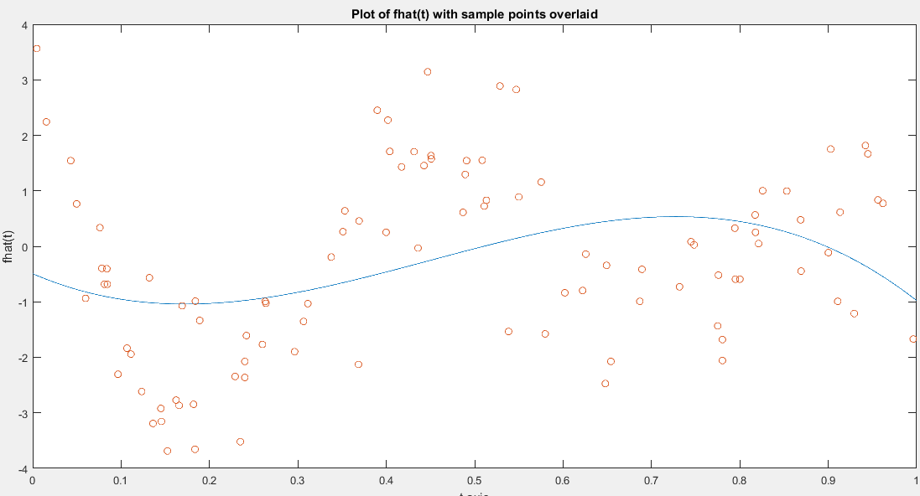

b) Generalization error: 1.293859993771946

c)

Polynomial of order p.

|  |  |  |  |  |
| --- | --- | --- | --- | --- |
| Order p | Sample error | Generalization error | Largest sing. value of A | Smallest sing. value of A |
| 4 | 12.1340 | 0.7725 | 12.1560 | 0.00176 |
| 5 | 10.2337 | 0.4208 | 12.3196 | 0.0031 |
| 6 | 9.4812 | 0.4018 | 12.4474 | 5.8977x10^-4 |
| 7 | 9.3540 | 0.3261 | 12.5503 | 1.1005x10^-4 |
| 8 | 9.3167 | 0.3327 | 12.6351 | 1.8578x10^-5 |
| 9 | 9.2539 | 0.3309 | 12.7063 | 3.22x10^-6 |

Plots:

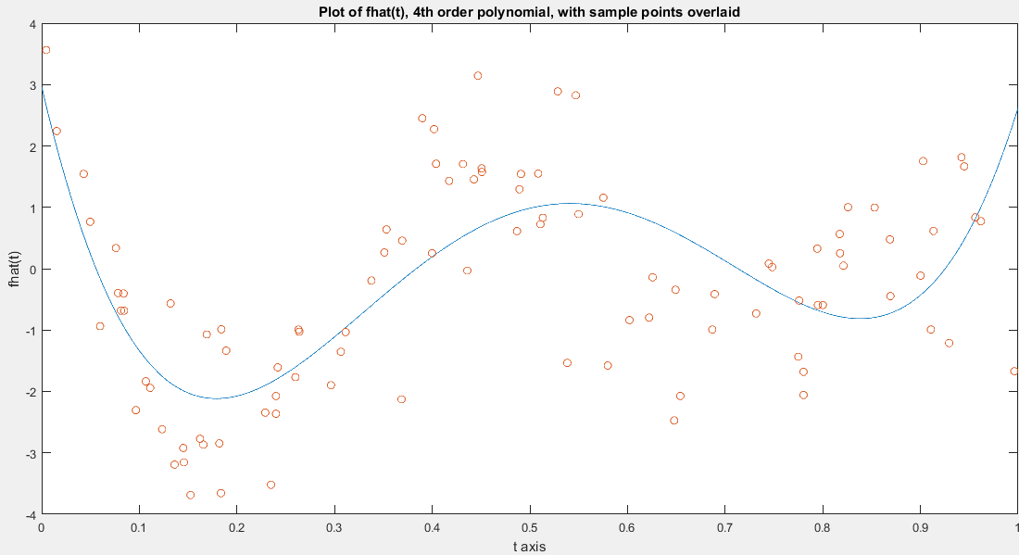

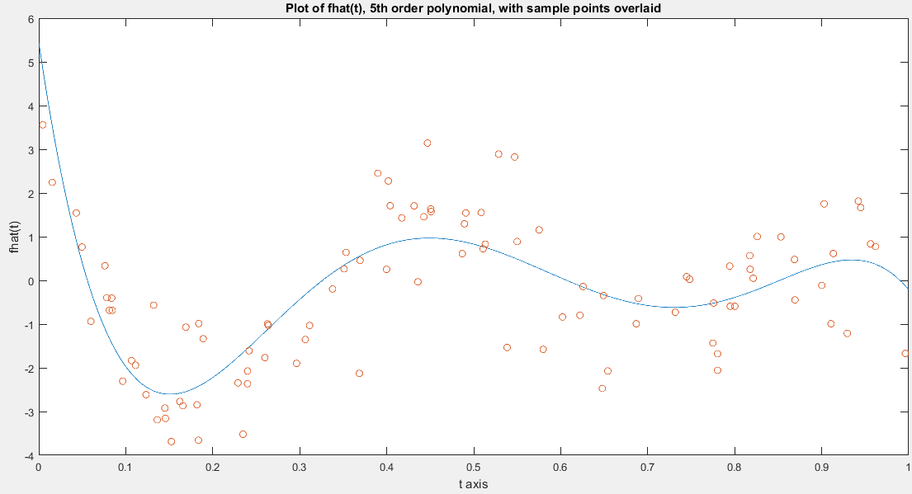

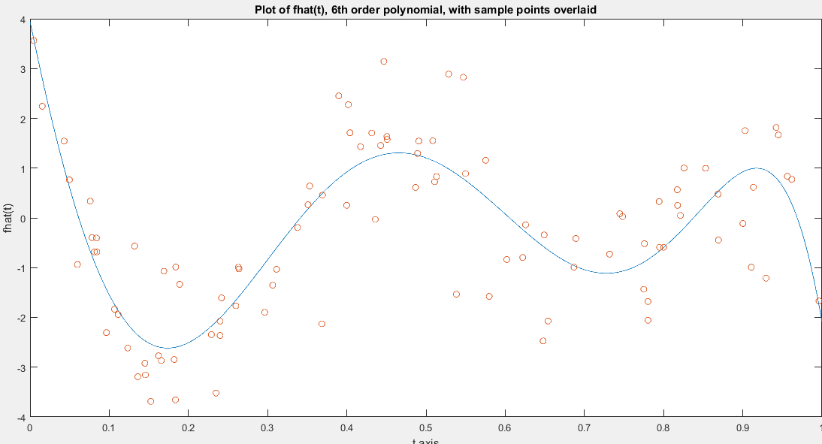

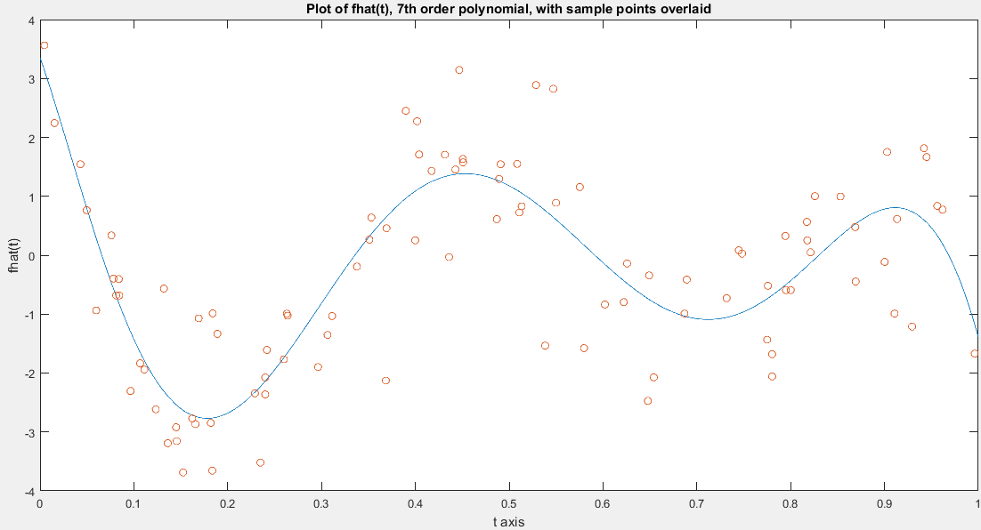

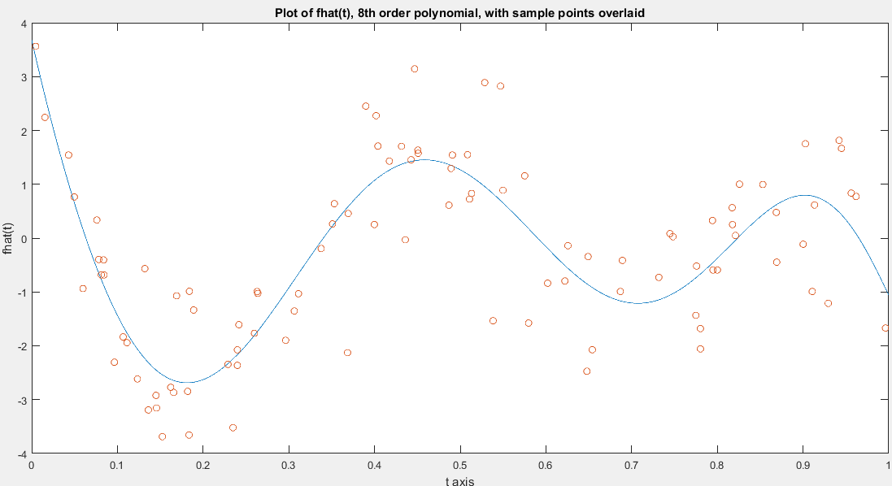

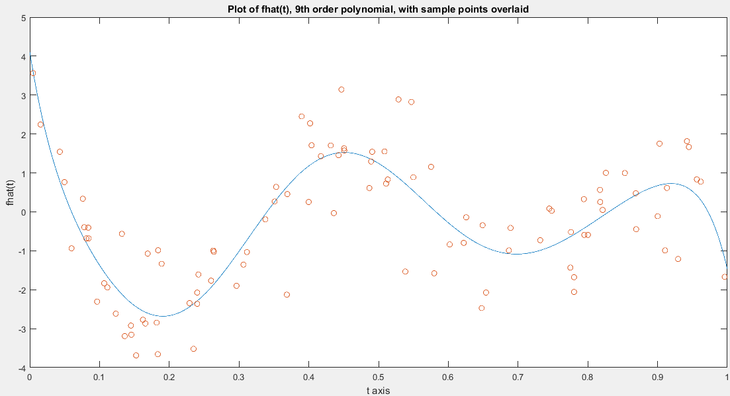

Comments:

For p = 8 and 9, the generalization error increases due to overfitting. But the sample error decreases as expected.

*Coefficients of the polynomial in decreasing powers of t:*

For p = 9:

-23798.7061897272 (coefficient of t^9)  
111140.870240860  
-215740.452048344  
223833.272265825  
-133081.773965033  
45550.6656529901  
-8918.34362142543  
1120.81742236563  
-111.928796857435  
4.10252141114323

For p = 8:

4486.79069046607  
-15941.5379390372  
20982.4060728154  
-12101.4684617239  
2617.74601894856  
-167.870806474144  
189.170029331071  
-69.9739802710004  
3.67715612192356

For p = 7:

1987.16478260814  
-8234.99009811957  
12844.8387557214  
-9304.47448018932  
2984.68950937058  
-236.000470185899  
-45.9737692145864  
3.35566453150577

For p = 6:

-1308.64088521456  
3300.24943619355  
-2713.78661916290  
603.624430019129  
190.089586673773  
-77.5780184278458  
3.94573775725840

For p = 5:

-582.906903286835  
1650.04046269520  
-1699.03484794543  
761.058736321338  
-134.810464992548  
5.43777459866408

For p = 4:

210.193595834972  
-436.753900569838  
294.523108705144  
-68.3034223143701  
2.96351442284634

d)

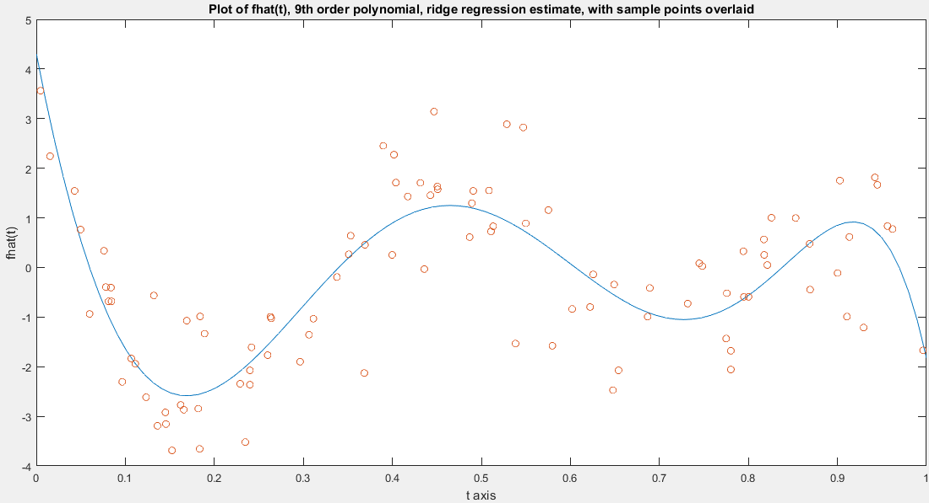

Largest singular value of A: 12.7063  
Smallest singular value of A: 3.22x10^-6  
Generalization error: 0.3854  
Sample error: 9.5167

e)

|  |  |  |  |  |  |
| --- | --- | --- | --- | --- | --- |
| Sigma value | 1/20 | 1/50 | 1/100 | 1/300 | 1/1000 |
| Sample error | 8.4528 | 6.6019 | 3.8359 | 1.4968 | 0.2951 |
| Generalization error | 0.5069 | 0.9975 | 1.8938 | 1.3260 | 1.1644 |

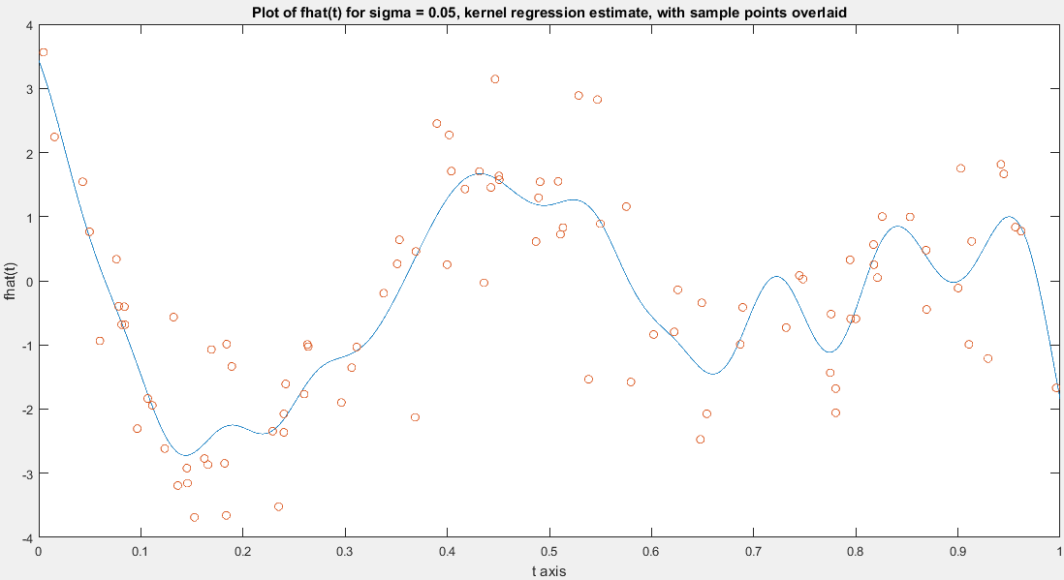

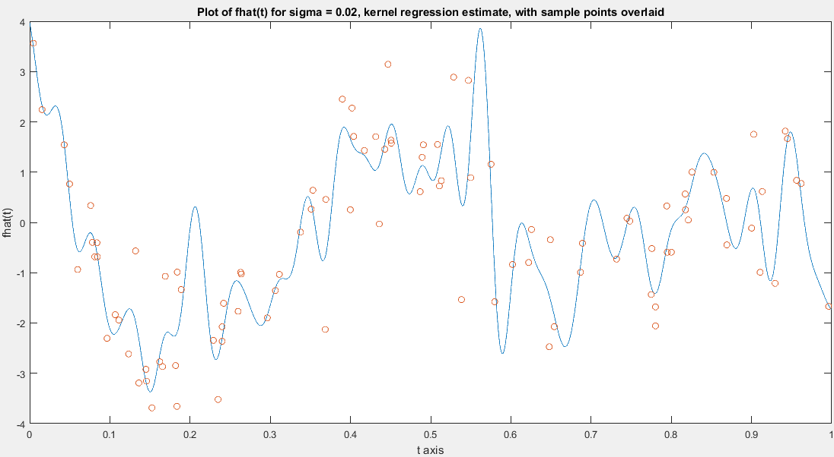

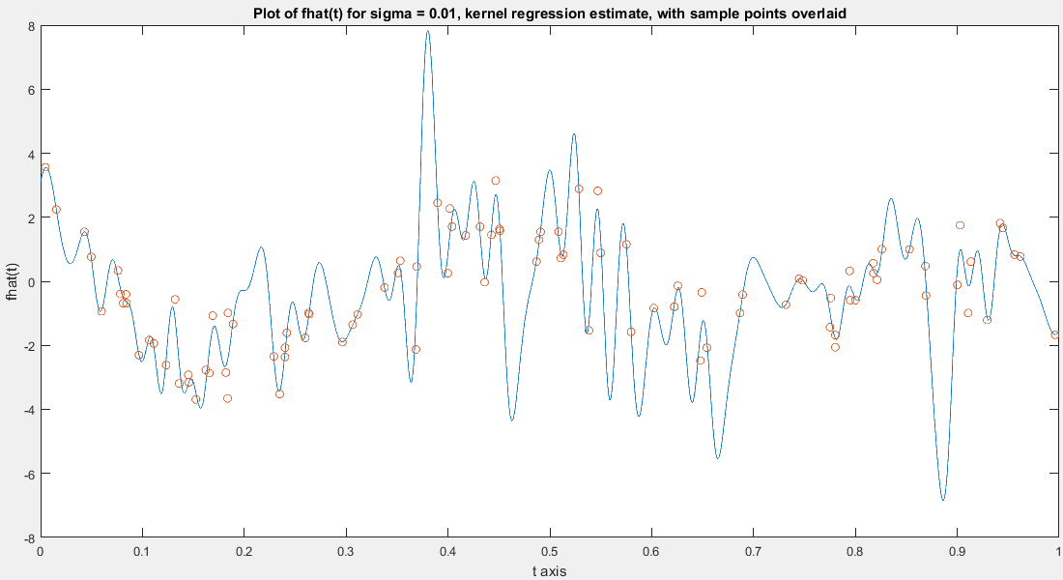

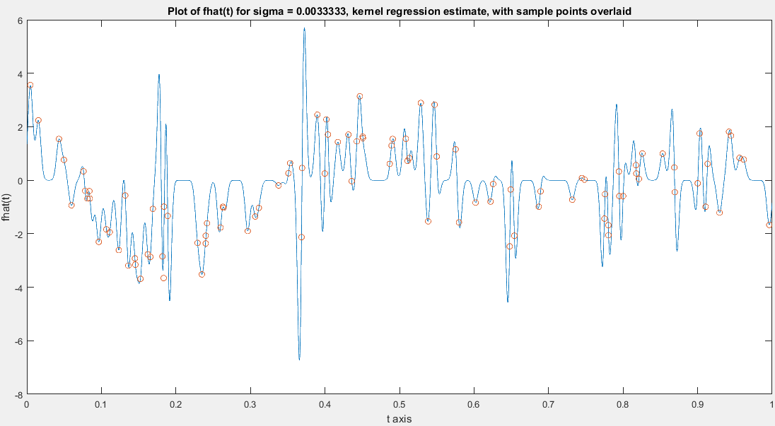

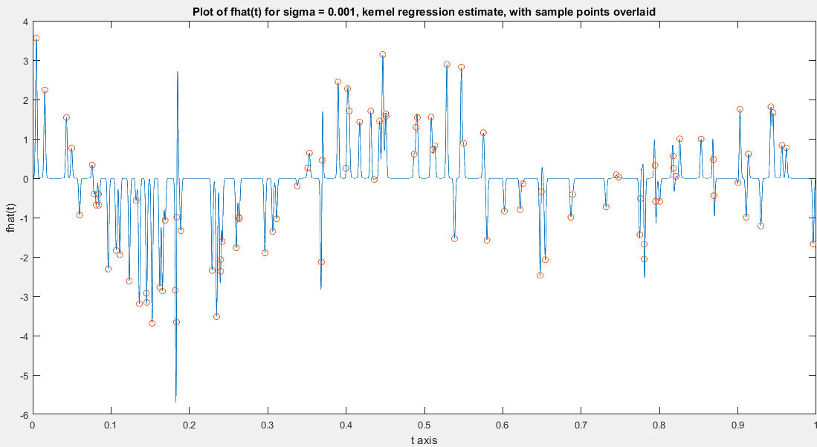

Comments:

As the plots clearly indicate, for sigma = 1/1000, almost all the points are fit by the curve. This is a case of overfitting. If we observe the generalization errors, we can see that they increase up to sigma = 1/100 and then decrease. So, we have a maximum overfitting at this sigma = 1/100. For very low sigma, the generalization error reduces because the functions become similar to spikes and they approximate a point well. The case of sample error shows that it decreases monotonically, as expected.

CODES:

4.A.

clear all

close all

load('hw5p4_data.mat');

for i=1:100

A(i,:) = [T(i)^3 T(i)^2 T(i) 1]; % ---- A is a 100x4 matrix.

end

B = pinv(A);

x = B*y;

se = 0;

%sample error:

for i=1:100

se = se + ((y(i) - (x(1)*(T(i)^3) + x(2)*(T(i)^2) + x(3)*(T(i)) + x(4)))^2);

end

sampleerror = sqrt(se);

t = linspace(0,1,5000);

plot(t,(x(1)*(t.^3) + x(2)*(t.^2) + x(3)*t + x(4)));

ylabel('fhat(t)');

xlabel('t axis');

title('Plot of fhat(t) with sample points overlaid');

hold on;

plot(T,y,'o');

4.B.

%For 3rd order polynomial

%Sampling 5000 points between 0 and 1 and at intervals of 1/5000.

t = linspace(0,1,5000);

for i = 1:5000

a1(i) = (x(1)*(t(i).^3) + x(2)*(t(i).^2) + x(3)*t(i) + x(4)) - ((sin(12*(t(i) + 0.2)))/(t(i) + 0.2));

b1(i) = a1(i)^2;

end

c1 = mean(b1);

generror3 = c1^(0.5);

4.C.

%For 4th order polynomial

for i=1:100

A1(i,:) = [T(i)^4 T(i)^3 T(i)^2 T(i) 1]; % ---- A is a 100x5 matrix.

end

B = pinv(A1);

x = B*y;

se = 0;

%sample error:

for i=1:100

se(i) = (y(i) - ((x(1)*(T(i)^4) + x(2)*(T(i)^3) + x(3)*(T(i)^2) + x(4)*(T(i)) + x(5))));

de(i) = se(i)^2;

end

sampleerrorA1 = sqrt(sum((de)));

figure;

t = linspace(0,1,5000);

plot(t,(x(1)*(t.^4) + x(2)*(t.^3) + x(3)*(t.^2) + x(4)*t + x(5)));

ylabel('fhat(t)');

xlabel('t axis');

title('Plot of fhat(t), 4th order polynomial, with sample points overlaid');

hold on;

plot(T,y,'o');

s = svd(A1);

smallestsingA1 = min(s);

largestsingA1 = max(s);

t = linspace(0,1,5000);

for i = 1:5000

a2(i) = (x(1)*(t(i).^4) + x(2)*(t(i).^3) + x(3)*(t(i).^2) + x(4)*t(i) + x(5)) - ((sin(12*(t(i) + 0.2)))/(t(i) + 0.2));

b2(i) = a2(i)^2;

end

c2 = mean(b2);

generror4 = sqrt(c2);

%For 5th order polynomial

for i=1:100

A2(i,:) = [T(i)^5 T(i)^4 T(i)^3 T(i)^2 T(i) 1]; % ---- A is a 100x6 matrix.

end

B = pinv(A2);

x = B*y;

se = 0;

%sample error:

for i=1:100

se(i) = (y(i) - ((x(1)*(T(i)^5) + x(2)*(T(i)^4) + x(3)*(T(i)^3) + x(4)*(T(i)^2) + x(5)*(T(i)) + x(6))));

de(i) = se(i)^2;

end

sampleerrorA2 = sqrt(sum((de)));

figure;

t = linspace(0,1,5000);

plot(t,((x(1)*(t.^5) + x(2)*(t.^4) + x(3)*(t.^3) + x(4)*(t.^2) + x(5)*(t) + x(6))));

ylabel('fhat(t)');

xlabel('t axis');

title('Plot of fhat(t), 5th order polynomial, with sample points overlaid');

hold on;

plot(T,y,'o');

s = svd(A2);

smallestsingA2 = min(s);

largestsingA2 = max(s);

t = linspace(0,1,5000);

for i = 1:5000

a3(i) = (x(1)*(t(i).^5) + x(2)*(t(i).^4) + x(3)*(t(i).^3) + x(4)*(t(i).^2) + x(5)*(t(i)) + x(6)) - ((sin(12*(t(i) + 0.2)))/(t(i) + 0.2));

b3(i) = a3(i)^2;

end

c3 = mean(b3);

generror5 = sqrt(c3);

%For 6th order polynomial

for i=1:100

A3(i,:) = [T(i)^6 T(i)^5 T(i)^4 T(i)^3 T(i)^2 T(i) 1]; % ---- A is a 100x7 matrix.

end

B = pinv(A3);

x = B*y;

se = 0;

%sample error:

for i=1:100

se(i) = (y(i) - ((x(1)*(T(i)^6) + x(2)*(T(i)^5) + x(3)*(T(i)^4) + x(4)*(T(i)^3) + x(5)*(T(i)^2) + x(6)*(T(i)) + x(7))));

de(i) = se(i)^2;

end

sampleerrorA3 = sqrt(sum((de)));

figure;

t = linspace(0,1,5000);

plot(t,((x(1)*(t.^6) + x(2)*(t.^5) + x(3)*(t.^4) + x(4)*(t.^3) + x(5)*(t.^2) + x(6)*t + x(7))));

ylabel('fhat(t)');

xlabel('t axis');

title('Plot of fhat(t), 6th order polynomial, with sample points overlaid');

hold on;

plot(T,y,'o');

s = svd(A3);

smallestsingA3 = min(s);

largestsingA3 = max(s);

t = linspace(0,1,5000);

for i = 1:5000

a4(i) = (x(1)*(t(i).^6) + x(2)*(t(i).^5) + x(3)*(t(i).^4) + x(4)*(t(i).^3) + x(5)*(t(i).^2) + x(6)*t(i) + x(7)) - ((sin(12*(t(i) + 0.2)))/(t(i) + 0.2));

b4(i) = a4(i)^2;

end

c4 = mean(b4);

generror6 = sqrt(c4);

%For 7th order polynomial

for i=1:100

A4(i,:) = [T(i)^7 T(i)^6 T(i)^5 T(i)^4 T(i)^3 T(i)^2 T(i) 1]; % ---- A is a 100x8 matrix.

end

B = pinv(A4);

x = B*y;

se = 0;

%sample error:

for i=1:100

se(i) = (y(i) - ((x(1)*(T(i)^7) + x(2)*(T(i)^6) + x(3)*(T(i)^5) + x(4)*(T(i)^4) + x(5)*(T(i)^3) + x(6)*(T(i)^2) + x(7)*(T(i)) + x(8))));

de(i) = se(i)^2;

end

sampleerrorA4 = sqrt(sum((de)));

figure;

t = linspace(0,1,5000);

plot(t,((x(1)*(t.^7) + x(2)*(t.^6) + x(3)*(t.^5) + x(4)*(t.^4) + x(5)*(t.^3) + x(6)*(t.^2) + x(7)*t + x(8))));

ylabel('fhat(t)');

xlabel('t axis');

title('Plot of fhat(t), 7th order polynomial, with sample points overlaid');

hold on;

plot(T,y,'o');

s = svd(A4);

smallestsingA4 = min(s);

largestsingA4 = max(s);

t = linspace(0,1,5000);

for i = 1:5000

a5(i) = (x(1)*(t(i).^7) + x(2)*(t(i).^6) + x(3)*(t(i).^5) + x(4)*(t(i).^4) + x(5)*(t(i).^3) + x(6)*(t(i).^2) + x(7)*t(i) + x(8)) - ((sin(12*(t(i) + 0.2)))/(t(i) + 0.2));

b5(i) = a5(i)^2;

end

c5 = mean(b5);

generror7 = sqrt(c5);

%For 8th order polynomial

for i=1:100

A5(i,:) = [T(i)^8 T(i)^7 T(i)^6 T(i)^5 T(i)^4 T(i)^3 T(i)^2 T(i) 1]; % ---- A is a 100x9 matrix.

end

B = pinv(A5);

x = B*y;

se = 0;

%sample error:

for i=1:100

se(i) = (y(i) - ((x(1)*(T(i)^8) + x(2)*(T(i)^7) + x(3)*(T(i)^6) + x(4)*(T(i)^5) + x(5)*(T(i)^4) + x(6)*(T(i)^3) + x(7)*(T(i)^2) + x(8)*(T(i)) + x(9))));

de(i) = se(i)^2;

end

sampleerrorA5 = sqrt(sum((de)));

figure;

t = linspace(0,1,5000);

plot(t,((x(1)*(t.^8) + x(2)*(t.^7) + x(3)*(t.^6) + x(4)*(t.^5) + x(5)*(t.^4) + x(6)*(t.^3) + x(7)*(t.^2) + x(8)*t + x(9))));

ylabel('fhat(t)');

xlabel('t axis');

title('Plot of fhat(t), 8th order polynomial, with sample points overlaid');

hold on;

plot(T,y,'o');

s = svd(A5);

smallestsingA5 = min(s);

largestsingA5 = max(s);

t = linspace(0,1,5000);

for i = 1:5000

a6(i) = (x(1)*(t(i).^8) + x(2)*(t(i).^7) + x(3)*(t(i).^6) + x(4)*(t(i).^5) + x(5)*(t(i).^4) + x(6)*(t(i).^3) + x(7)*(t(i).^2) + x(8)*t(i) + x(9)) - ((sin(12*(t(i) + 0.2)))/(t(i) + 0.2));

b6(i) = a6(i)^2;

end

c6 = mean(b6);

generror8 = sqrt(c6);

%For 9th order polynomial

for i=1:100

A6(i,:) = [T(i)^9 T(i)^8 T(i)^7 T(i)^6 T(i)^5 T(i)^4 T(i)^3 T(i)^2 T(i) 1]; % ---- A is a 100x10 matrix.

end

B = pinv(A6);

x = B*y;

se = 0;

%sample error:

for i=1:100

se(i) = (y(i) - ((x(1)*(T(i)^9) + x(2)*(T(i)^8) + x(3)*(T(i)^7) + x(4)*(T(i)^6) + x(5)*(T(i)^5) + x(6)*(T(i)^4) + x(7)*(T(i)^3) + x(8)*(T(i)^2) + x(9)*(T(i)) + x(10))));

de(i) = se(i)^2;

end

sampleerrorA6 = sqrt(sum((de)));

figure;

t = linspace(0,1,5000);

plot(t,((x(1)*(t.^9) + x(2)*(t.^8) + x(3)*(t.^7) + x(4)*(t.^6) + x(5)*(t.^5) + x(6)*(t.^4) + x(7)*(t.^3) + x(8)*(t.^2) + x(9)*t + x(10))));

ylabel('fhat(t)');

xlabel('t axis');

title('Plot of fhat(t), 9th order polynomial, with sample points overlaid');

hold on;

plot(T,y,'o');

s = svd(A6);

smallestsingA6 = min(s);

largestsingA6 = max(s);

t = linspace(0,1,5000);

for i = 1:5000

a7(i) = (x(1)*(t(i).^9) + x(2)*(t(i).^8) + x(3)*(t(i).^7) + x(4)*(t(i).^6) + x(5)*(t(i).^5) + x(6)*(t(i).^4) + x(7)*(t(i).^3) + x(8)*(t(i).^2) + x(9)*t(i) + x(10)) - ((sin(12*(t(i) + 0.2)))/(t(i) + 0.2));

b7(i) = a7(i)^2;

end

c7 = mean(b7);

generror9 = sqrt(c7);

4.D.

del = 10^(-6)*eye(100);

%For 9th order polynomial

for i=1:100

Anew(i,:) = [T(i)^9 T(i)^8 T(i)^7 T(i)^6 T(i)^5 T(i)^4 T(i)^3 T(i)^2 T(i) 1]; % ---- Anew is a 100x10 matrix.

end

B = Anew'*inv((Anew*Anew') + del);

x = B*y;

se = 0;

%sample error:

for i=1:100

se(i) = (y(i) - ((x(1)*(T(i)^9) + x(2)*(T(i)^8) + x(3)*(T(i)^7) + x(4)*(T(i)^6) + x(5)*(T(i)^5) + x(6)*(T(i)^4) + x(7)*(T(i)^3) + x(8)*(T(i)^2) + x(9)*(T(i)) + x(10))));

de(i) = se(i)^2;

end

sampleerrorAnew = sqrt(sum((de)));

figure;

t = linspace(0,1);

plot(t,((x(1)*(t.^9) + x(2)*(t.^8) + x(3)*(t.^7) + x(4)*(t.^6) + x(5)*(t.^5) + x(6)*(t.^4) + x(7)*(t.^3) + x(8)*(t.^2) + x(9)*t + x(10))));

ylabel('fhat(t)');

xlabel('t axis');

title('Plot of fhat(t), 9th order polynomial, ridge regression estimate, with sample points overlaid');

hold on;

plot(T,y,'o');

s = svd(Anew);

smallestsingAnew = min(s);

largestsingAnew = max(s);

t = linspace(0,1,5000);

for i = 1:5000

a8(i) = (x(1)*(t(i).^9) + x(2)*(t(i).^8) + x(3)*(t(i).^7) + x(4)*(t(i).^6) + x(5)*(t(i).^5) + x(6)*(t(i).^4) + x(7)*(t(i).^3) + x(8)*(t(i).^2) + x(9)*t(i) + x(10)) - ((sin(12*(t(i) + 0.2)))/(t(i) + 0.2));

b8(i) = a8(i)^2;

end

c8 = mean(b8);

generrord = sqrt(c8);

4.E.

sigma = [1/20 1/50 1/100 1/300 1/1000];

for k = 1:5

for i = 1:100

for j = 1:100

K(i,j) = exp(-((T(i)-T(j))^2)/(2*sigma(k)*sigma(k)));

end

end

e = eig(K);

del(k) = max(e)/1000;

delta = del(k)*eye(100);

B = inv(K + delta);

alpha = B*y;

for i = 1:100

ft(i) = 0;

for j = 1:100

ft(i) = ft(i) + (alpha(j) * exp(-((T(i)-T(j))^2)/(2*sigma(k)*sigma(k))));

end

end

se = 0;

for i=1:100

se = se + ((y(i) - ft(i))^2);

end

sampleerror(k) = sqrt(se);

tx = linspace(0,1,5000);

for i = 1:5000

ft(i) = 0;

for j = 1:100

ft(i) = ft(i) + (alpha(j) * exp(-((T(j)-tx(i))^2)/(2*sigma(k)*sigma(k))));

end

end

%Sampling 5000 points between 0 and 1 and at intervals of 1/5000.

t = linspace(0,1,5000);

for i = 1:5000

ax = (ft(i) - ((sin(12*(t(i) + 0.2)))/(t(i) + 0.2)));

b(i) = ax^2;

end

c = mean(b);

generror(k) = c^(0.5);

figure;

t = linspace(0,1,5000);

plot(t,ft);

ylabel('fhat(t)');

xlabel('t axis');

title(['Plot of fhat(t) for sigma = ' num2str(sigma(k)) ', kernel regression estimate, with sample points overlaid']);

hold on;

plot(T,y,'o');

end